Experiment No 9

AIM: To determine the frequency of A.C. mains using an electric vibrator.
APPRATUS: An electric vibrator, a thread, pan, weight box, a frictionless pulley, meter scale.

THEORY:
A.C. (Alternating Current): An alternating current (AC) is an electrical current whose magnitude and direction vary cyclically, as opposed to direct current, whose direction remains constant. The usual waveform of an AC power circuit is a sine wave, as this results in the most efficient transmission of energy. Most students of electricity begin their study with what is known as direct current (DC), which is electricity flowing in a constant direction, and/or possessing a voltage with constant polarity. DC is the kind of electricity made by a battery (with definite positive and negative terminals), or the kind of charge generated by rubbing certain types of materials against each other. As useful and as easy to understand as DC is, it is not the only “kind” of electricity in use. Certain sources of electricity (most notably, rotary electro-mechanical generators) naturally produce voltages alternating in polarity, reversing positive and negative over time. Either as a voltage switching polarity or as a current switching direction back and forth, this “kind” of electricity is known as Alternating Current (AC): Figure 1 below:
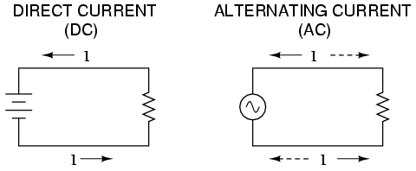
Direct vs. Alternating Current.
Figure 1.

Whereas the familiar battery symbol is used as a generic symbol for any DC voltage source, the circle with the wavy line inside is the generic symbol for any AC voltage source.

Electric Vibrator: An electric vibrator consists of a solenoid S & thin steel rod R set along the axis of solenoid (Figure 2 below). The rod is clamped by using the binding screw B on one side but free at the other end. The free end of the rod is slightly flattened & a hole H is drilled in it. A permanent horse shoe magnet NS is mounted on the base board symmetrically so that the steel rod passes between its poles. The solenoid is fed by A.C. mains through a suitable lamp resistance L.
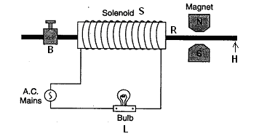
Figure 2.

When an alternating current flows through the solenoid coil, the steel rod is magnetized with its magnetic polarity being reversed after each half cycle of alternating currents. Due to the interaction between the magnetism of rod and the horse shoe magnet, the steel rod R starts vibrating with frequency of A.C. mains. The rod executes forced vibrations but on adjusting the length of the rod, which is free to vibrate, resonance can be obtained when normal vibration frequency of the rod becomes exactly same as the frequency of A.C. mains. Consequently, the vigorous vibrations take place at the free end of the rod and the vibrator maintains continuous vibrations at the expense of energy supplied by A.C. mains.

Nodes and antinodes: When a string stretched between two fixed points is plucked in a direction at right angles to its length, stationary transverse vibrations are set up in it (Figure 3 below). The string may vibrate as a whole in one segment as shown in fig (i). The frequency of sound produced by the string in this case is lowest and is called fundamental. It may vibrate in two or more segments as shown in fig (ii) and (iii).In these cases the frequency of sound produced will be double and three times the fundamental frequency respectively. These frequencies are known as overtones and harmonics.

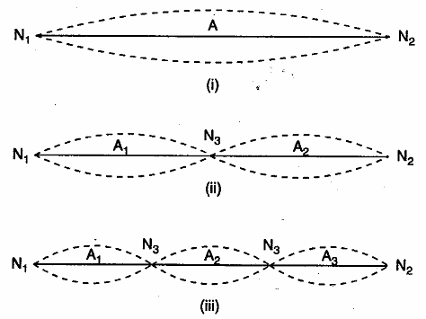

Figure 3.

The fixed points like N₁, N₂…… etc. where the amplitude is zero but the strain is maximum are called nodes and points like A₁, A₂, A₃…..etc. where the amplitude is maximum but the strain is the least are called antinodes.

When the alternating current is passed, the steel rod executes vibrations which pass over to the thread. The wave traveling along the thread is reflected by the pulley. Thus, the stationary waves are formed in the thread with pulley & the end of the vibrator as nodes. Depending on the length of thread & the tension i.e. the mass suspended in the pan, the thread may vibrate in a no. of loops. The length of the thread between vibrator rod and the pulley is adjusted till the thread vibrates in a definite no. of loops with maximum amplitude at the antinodes i.e. resonance takes place and sharp nodes and antinodes are formed. In this arrangement the frequency of the thread is same as that of electric vibrator i.e. same as that of the A.C. mains. Thus
Frequency of the A.C. mains (f) = Frequency of the thread (n)

Transverse Arrangement: The arrangement in which the steel rod executes vibrations in a direction perpendicular to the direction of propagation of the wave (or the length of the string) is called transverse arrangement as shown in figure 4 below.

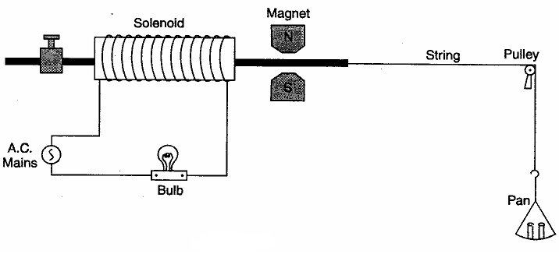
Figure 4.

The time during which the steel rod completes one vibration, the thread also complete one vibration. If ‘l’ is the length between two consecutive nodes, ‘T’ the tension present in the thread and ‘m’ its mass per unit length, then frequency of the vibration of the thread is given by the relation
$$n=\frac{1}{2l}\sqrt{\frac{T}{m}}$$
Frequency of A.C. mains (f) = $n=\frac{1}{2l}\sqrt{\frac{T}{m}}$

Longitudinal Arrangement: The arrangement in which the steel rod executes vibrations in a direction parallel to the direction of propagation of the wave (or the length of the string) is called longitudinal arrangement as shown in figure 5 below.
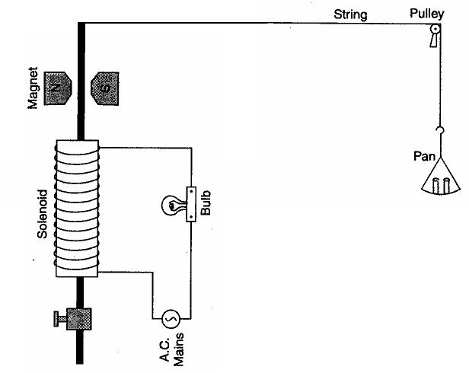

Figure 5.

The time, during which the steel rod completes one vibration, the thread completes half a vibration. Hence the frequency of the thread is half that of the steel rod. If the same length l if the thread vibrates in one loop under a tension T then frequency of the vibration of the thread is given by the relation
n = 2 × Frequency of the thread
or $n=2×\frac{1}{2l}\sqrt{\frac{T}{m}}$
$$n=\frac{1}{l}\sqrt{\frac{T}{m}}$$
Frequency of A.C. mains (f) = $n=\frac{1}{l}\sqrt{\frac{T}{m}}$

PROCEDURE:
- Tie one end of the thread of about 2 meter length to the free end of the steel rod in electric vibrator and other end of the thread to a light aluminum pan. Suspend it freely after passing it over a frictionless pulley fixed at the edge of the table.
- See that the height of the pulley is such that the cord remains horizontal.
- Make the electric connections of the electric vibrator and adjust clamping screws provided in it such that the steel rod of the vibrator starts vibrating with sufficiently large amplitude.
- Set the steel rod of the electric vibrator in line with the thread as shown in figure 4 such that about 1.5 meter length of thread lies between the vibrator and the pulley. The apparatus is now set for transverse arrangement. The direction of vibration of the vibrator rod is at the right angle to the length of thread. This arrangement is known as the transverse arrangement.
- Place weights in the pan. The cord vibrates. Usually the amplitude of vibrations of the thread is very small. Adjust weight in the pan slowly in small steps till the vibrations of maximum amplitude are obtained. The thread vibrates in a finite no. of loops and sharp nodes and antinodes are formed.
- Mark the position of the nodes leaving out the two extremes loops (i.e. the loop formed near the vibrator and the loop formed near the pulley). Count the no. of loops formed between these marks. Switch off the current and measure the distance between the marks carefully using a meter scale. Divide the distance by the counted no. of loop and find the value of l. Note the mass placed in the pan.
- Repeat the steps no. 5 and 6 for different loops. Different no. of loops may be formed either by changing the mass put in the pan or by changing the length of cord.
- Find the mass of pan using sensitive balance.
- Find the mass of a known length (about two meter) of the thread and calculate m, the mass/unit length of the thread.
- Now apply the appropriate formula for transverse and calculate the frequency of A.C. mains.
- Repeat the steps no.4-9 for longitudinal arrangement as shown in figure 5.
- Now apply the appropriate formula for longitudinal and calculate the frequency of A.C. mains.

OBSERVATIONS AND CALCULATIONS:
Mass of the pan M₁=
Mass per unit length of the thread m =

Transverse Arrangement
 | S.No. | Mass placed in the pan M₂ (gm) | Total Tension  T = (M₁ + M₂)g | No. of Loops ‘P’ | Corresponding length of thread ‘L’ (cm) | Length of one loop ‘l’ = L/P | Frequency  $f=\frac{1}{2l}\sqrt{\frac{T}{m}}$ Hz
I | 1
I | 2
I | 3
II | 1
II | 2
II | 3

Mean frequency of A.C. Mains determined in transverse arrangement f = ……….. Hz

Longitudinal Arrangement
 | S.No. | Mass placed in the pan M₂ | Total Tension  T = (M₁ + M₂)g | No. of Loops ‘P’ | Corresponding length of thread ‘L’ (cm) | Length of one loop ‘l’ = L/P | Frequency  $f=\frac{1}{l}\sqrt{\frac{T}{m}}$ Hz
I | 1
I | 2
I | 3
II | 1
II | 2
II | 3

Mean frequency of A.C. Mains determined in longitudinal arrangement f = ……….. Hz

RESULTS:
Transverse Arrangement
Experimental determined value of frequency of A.C. mains in transverse arrangement, f =…..Hz
Standard value of frequency of A.C. mains = 50 Hz
Percentage error in longitudinal arrangement =
(Experimental value - Standard value)/ Standard value

Longitudinal Arrangement
Experimental determined value of frequency of A.C. mains in longitudinal arrangement, f =…Hz
Standard value of frequency of A.C. mains = 50 Hz
Percentage error in transverse arrangement =
(Experimental value - Standard value)/ Standard value

PRECAUTION AND SOURCES OF ERROR:
- Flexible, inextensible thread of uniform thickness should be used.
- The pulley should be frictionless and thread between vibrator and pulley should be perfectly horizontal.
- Sharply defined nodes and antinodes should be noted. The loops formed in the thread with maximum amplitude at the antinodes should be noted.
- Do not put too much load in the pan.

VIVA VOCE:
- What is the difference between AC and DC?
- What are stationary waves? How these are formed?
- What are nodes and antinodes?
- What do you mean by solenoid? What is the magnetic field at the centre of the solenoid?
- Why a bulb is introduced in the circuit?
- What are transverse and longitudinal waves?
- What is the function of horse shoe magnet in the circuit?

